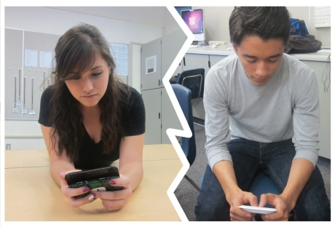
Somerset Hunterdon Psychological Association
Luncheon Conference - December 11, 2015
Breaking up is Hard to Do…
Jeffrey Segal, Psy.D
Breaking up is hard to do – especially if you are a teenager in 2015. Heartbreak is often the end result in any intimate relationship but the current technology and types of social media make breaking up even more difficult for teens today. Since people can be connected 24/7, when teens break up not only does the constant buzzing of their cell phones end but the demise is often for the world to see. In this presentation, some of the challenges in working with teenagers (and their parents) who experience breakups will be discussed along with recommendations for teaching resiliency.
Objectives
- Gain familiarity with current state of teenage relationships and the effects of technology and social media.
- Discuss ways to help the teenager cope with breakups in healthy ways.
- Discuss how to help parents be most effective in supporting their teen through a breakup.
Date: Friday, Dec 11, 2015
Time: 11:30- 12:00 PM Registration and Welcome
12:00-1:00 PM Lunch – Presentation & Luncheon 1:00 – 3:00 pm
Location: Beaver Brook Country Club 25 Country Club Road Clinton, NJ 08801
Cost: $30.00 SHPA members / $40.00 non-members
About the Speaker: Jeff Segal is a licensed psychologist in practice for more than 25 years. He works with children, adolescents and families in outpatient therapy. He consults to early childhood centers and schools and has provided more than 200 workshops and trainings on bullying, anxiety and depression in children and adolescents, parenting skills, young children and violence, adolescent brain development and other topics. In addition, for many years Dr. Segal was the coordinator of outpatient and intensive outpatient mental health services for Atlantic Health Systems at Morristown Memorial Hospital and Overlook Hospital. He currently consults to the Valerie Center at Morristown Memorial Hospital, a program for children and adolescents with cancer and blood disorders. For the past 20 years Dr. Segal has been a lead instructor for ACT-Parents Raising Safe Kids Program, a violence prevention program developed by the American Psychological Association and coordinated by Child & Family Resources, a non-profit agency in Mt. Arlington, NJ. He maintains a private practice in Morristown and works with children, adolescents, adults and their families in outpatient psychotherapy.
Registration: To reserve a space please contact Mark Aronson by Dec 8th at msaronson1@gmail.com. You may also preregister by sending a check payable to SHPA to: Mark Aronson, Ed.D. 12 Quimby Lane Bernardsville, NJ 07924

